Christiaan Versfeld, Muhammed Bhula, Ruan Zwarts, Phuti Motimele

[ST10091991@vcconnect.edu.za](mailto:ST10091991@vcconnect.edu.za), [ST10073908@vcconnect.edu.za](mailto:ST10073908@vcconnect.edu.za), [ST10158660@vcconnect.edu.za](mailto:ST10158660@vcconnect.edu.za), [ST10191686@vcconnect.edu.za](mailto:ST10191686@vcconnect.edu.za)

Abstract

A detailed research document that is made for OPSC POE PART 1 research aspect that undergoes a study of 3 chosen applications with extensive research and information gathering in the aid of providing a solution to an applicational design and implementation.

OPSC Group E

Research - ClockSavvy

Table of Contents

# Introduction (Pg 2)

# Applications (Pg 2)

## Application Overview (Pg 2 – 7)

## Application Innovative Features (Pg 7 – 10)

## Application Pro’s and Con’s (Pg 10 – 12)

## Application Infographics (Pg 12 – 13)

# Best Features to include. (Pg 13 – 18)

# Conclusion (Pg 18)

5 Reference List (Pg 18 – 21)

## **1.Introduction**

Time management is an essential aspect for individuals who aim to enhance productivity and improve efficiency in their personal as well as professional life. Time tracking applications allow individuals to better manage and prioritise their tasks through their mobile device or personal computer. These time tracking applications provide individuals the ability to monitor, analyse and optimise their productivity with ease.

In this research report, research will be done to see the effectiveness of 3 existing major time tracking applications that are used in the real world, we will be diving deeper into which features of these applications are the most effective that users find while using these applications. The report will also be going into the weaknesses of each app to determine which features need to be worked on or solved . These features will then be re-engineered into the development of an application and its importance will be implemented. Where any weaknesses are identified they will be looked into and redeveloped into a more useful or user-friendly way or left out completely.

## **2.Application**

**2.1. Overview**

Timely:

This program is primarily concerned with automated time tracking and visual job planning. It counts the amount of time you spend on tasks automatically and has a calendar-based interface where you can set aside time for them. For individuals and small teams who prefer automated time tracking with minimum manual input and a visual schedule depiction, this is perfect. (Timelyapp, 2024)

Users can monitor all project in real time as they are being worked on.

(Play, 2019)

All the time spent on different tasks is shown to users to better understand where most to least time is spent. From here, users can see where time adjusting Is needed.

(Play, 2019)

TOGGL Track:

This app places a high value on usability and simplicity. Basic functionality including time tracking, project management, and reports are included under its free plan. It's an excellent option for independent contractors and small teams who want a simple and efficient approach to manage their time because of its user-friendly layout and functionality. (Toggl, 2024)

A list of all activity is displayed for the user along with time spent on those task/projects.

(Play, 2024)

Users can use reports to better allocate time in projects that are falling behind.

(Play, 2024)

Harvest:

Harvest: This application is well-known for its compatibility with Asana and Trello, two well-liked project management platforms. It is easy for teams that currently use those platforms because it lets you track time right within your project management workflow. It supports project-based work and streamlines timekeeping in the context of the current project management system (Harvest, 2024).

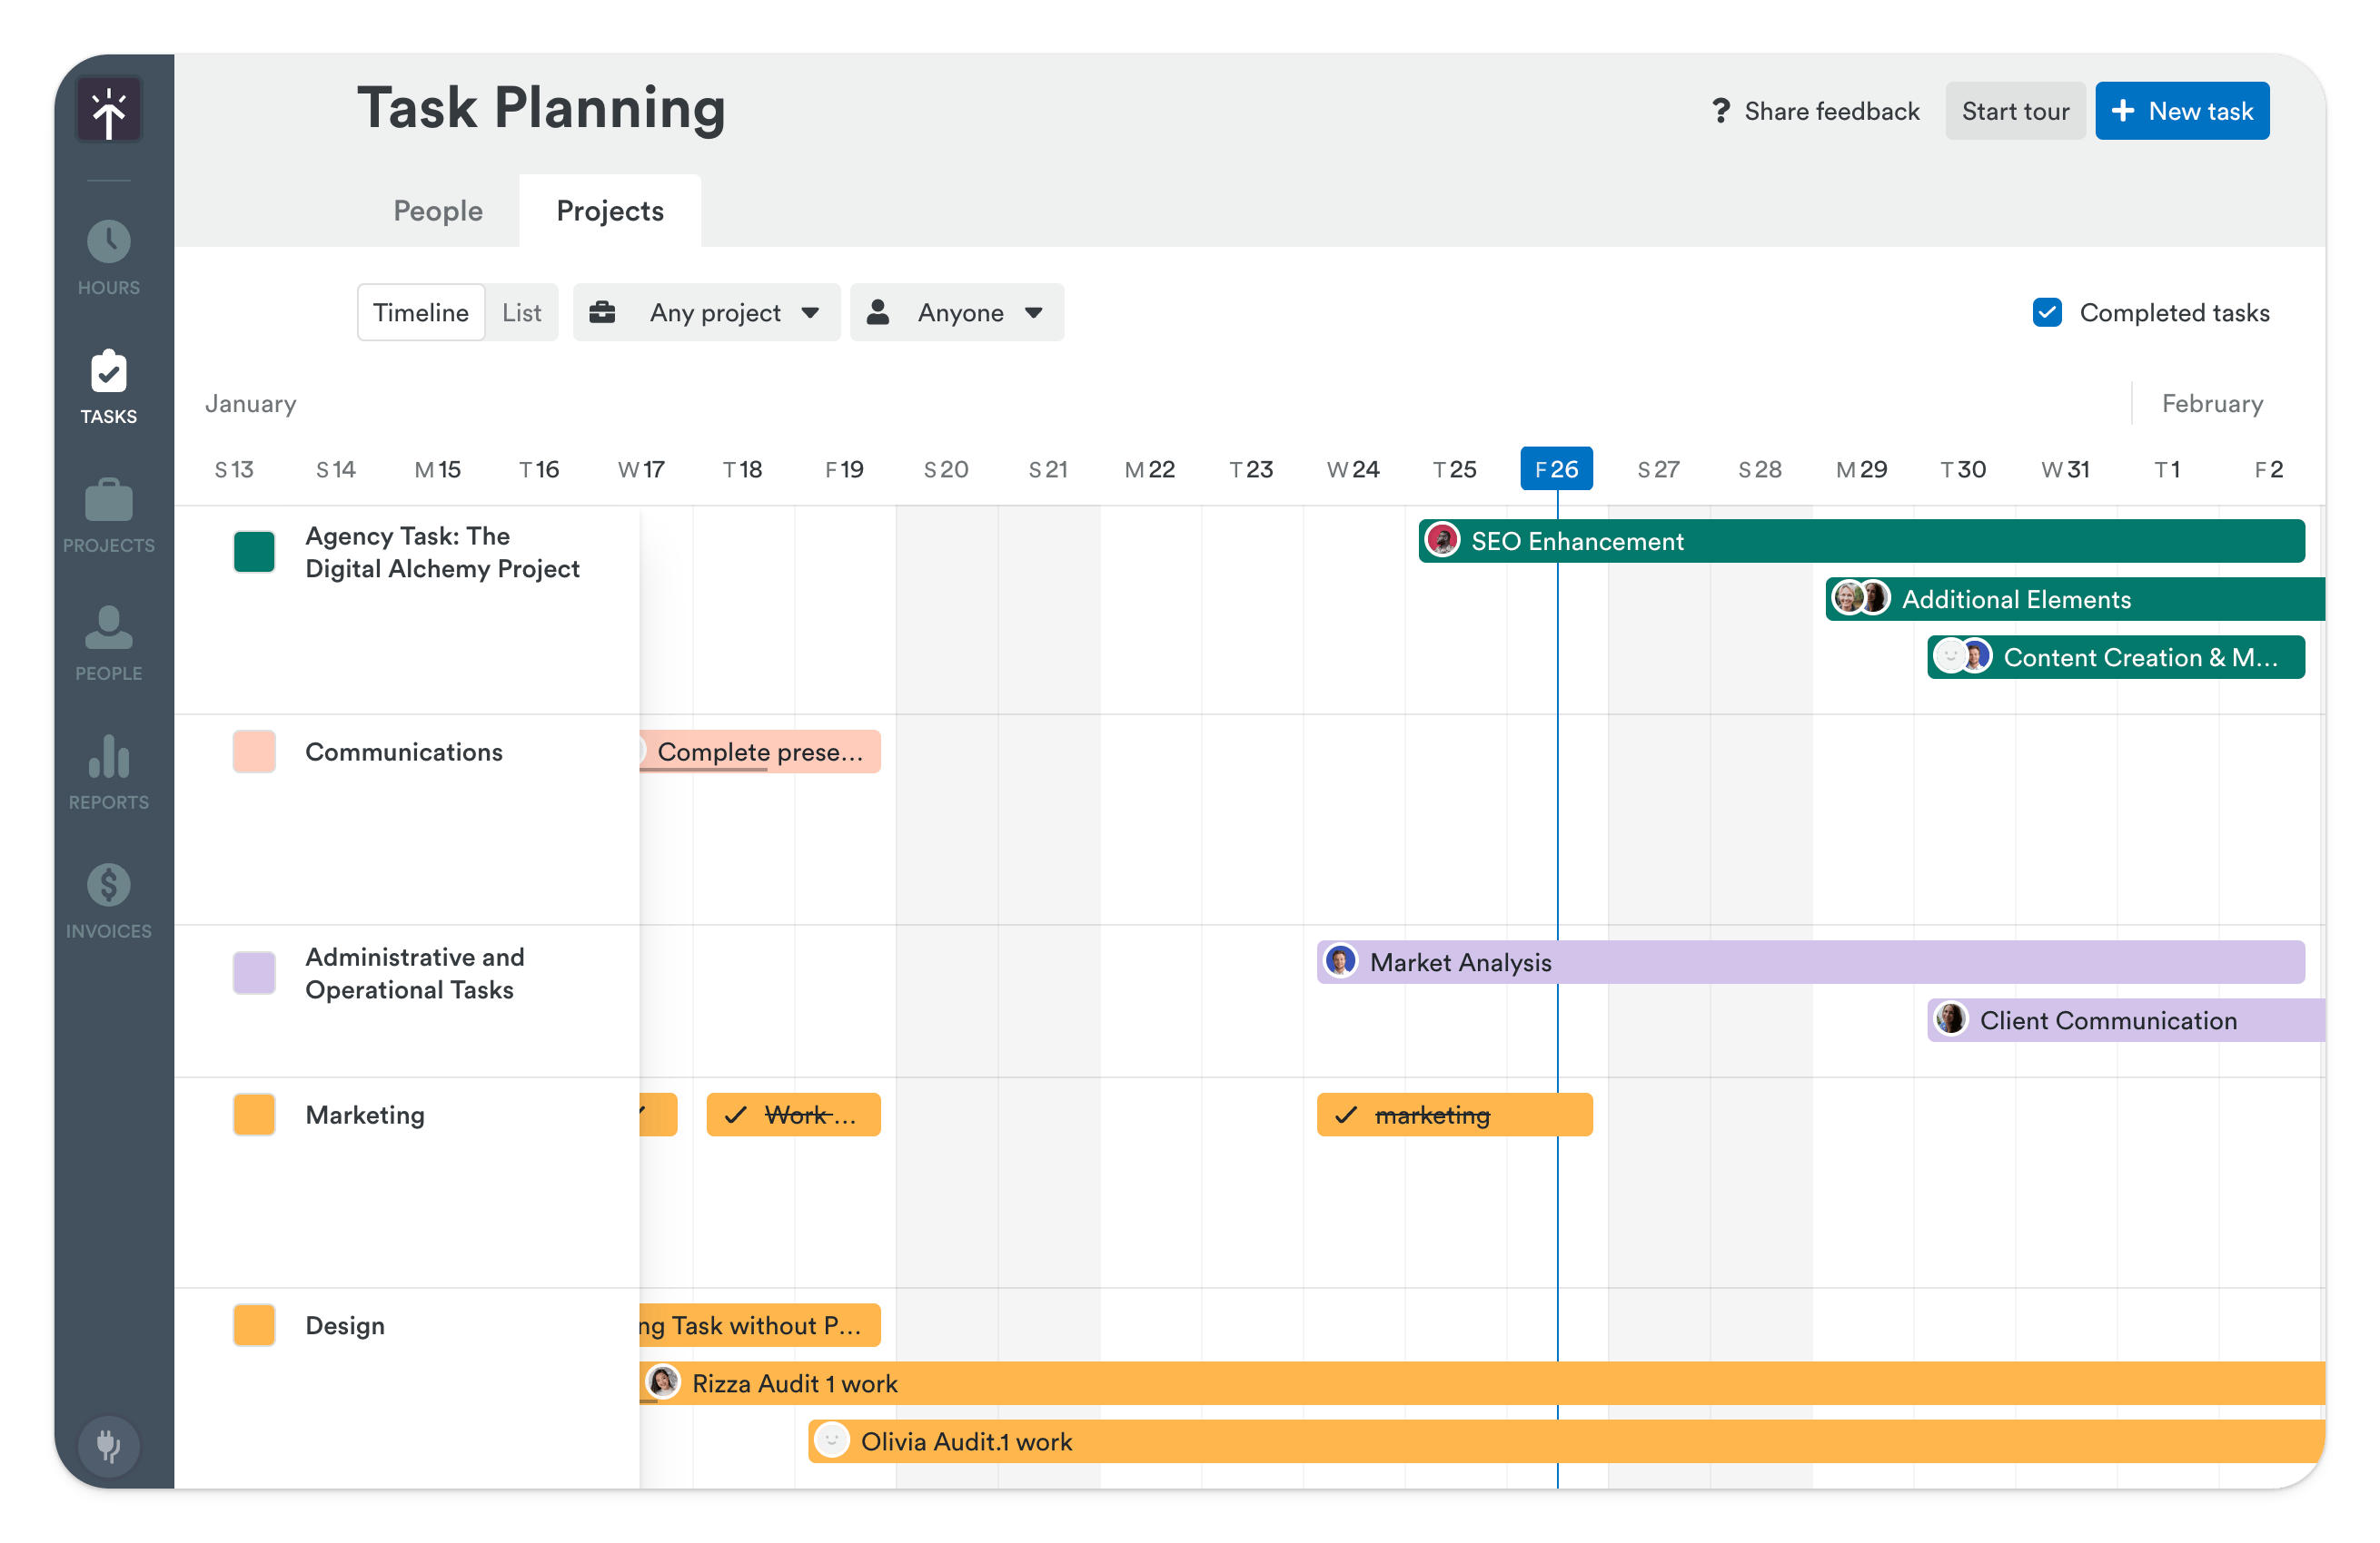

Users can log hours of all the time spent on tasks and projects.

(Google, 2024)

**2.2. Innovative features**

**Timely**

1. Memory AI: Timely makes use of memory AI technology to create, categorize and track various tasks allowing improved accuracy and efficiency for time tracking features (Timely, 2024).
2. AI Timesheets: Timely uses an AI-driven system that discerns the nature of various tasks and assigns them to their respective project (Timely, 2024).

* Using AI this innovative feature cuts out the redundant process of manually assigning and categorizing tasks individually to their specific project. Overall, this advanced feature revolutionizes the standard time tracking approach, making it more efficient (Timely, 2024).

1. AI Virtual Assistant: Timely makes use of an AI virtual assistant which users can rely on to allocate and update their activities in the background without the user having to manually make changes to the workflow captures.

* This innovative feature provides a better utilization of the user’s time (Timely, 2024).

1. Memory tracker: Timely has a built-in memory tracker which provides users with a way to optimize their workflows through identifying any bottlenecks in productivity (Timely, 2024).

* This innovative feature enhances efficiency by empowering users to streamline their processes and maximize their productivity.
* This in turn leads to an overall improvement in performance.

(Timely, 2024)

1. Time Planning: Timely has strong project planning capabilities which grants users the ability to estimate and set out a time slot for not only the current tasks of a project but also future tasks (Timely, 2024).

* This aids with resource management.

(Timely, 2024)

**Harvest**

1. Comprehensive Reporting and Analytics: Harvest has extensive reporting and analytics features, which allow users to

* gather insights into their time utilization patterns,
* Users can generate detailed reports to analyse their productivity,
* identify trends and make data-driven decisions to optimize their workflow.

(Harvest, 2024)

1. Time Blocking: Harvest makes use of a time blocking feature,

* enabling users to allocate specific time slots for different tasks and projects.
* This feature promotes focused work and helps users with prioritizing their activities, leading to improved efficiency and productivity.

(Harvest, 2024)

1. Integration Capabilities: Harvest allows the integration of their application with popular productivity tools such as Google Calendar and Trello (Harvest, 2024).

* This integration allows users to synchronize their schedules and tasks across multiple platforms, ensuring consistency and accessibility.

(Harvest, 2024).

1. Collaboration Features: Harvest offers collaboration features enabling team members to coordinate and track their joined time usage (Harvest, 2024).

* This functionality facilitates project management and resource allocation within teams, enhancing collaboration and productivity.

(Harvest, 2024)

**Toggl Track**

1. Time Tracking by Client: Toggl Track allows users to track time spent on tasks by client, enabling efficient project management and accurate billing (Toggl Track, 2024).

* This feature ensures that users can easily differentiate and attribute their time to specific clients or projects, streamlining invoicing and client communication processes.

(Toggl Track, 2024).

1. Browsing History: Toggl Track offers a unique browsing history feature that tracks the websites visited during a time tracking session (Toggl Track, 2024).

* This capability provides users with additional context and insights into their work habits, allowing them to better understand how they allocate their time online and make informed decisions to improve productivity.

(Toggl Track, 2024).

1. Summary Reports: Toggl Track generates comprehensive summary reports that provide users with detailed insights into their time usage and productivity (Toggl Track, 2024). These reports offer valuable analytics, including:

* total hours worked,
* task breakdowns,
* and project summaries,
* empowering users to analyze their performance and identify areas for improvement.

(Toggl Track, 2024).

1. Timer: Toggl Track includes a user-friendly timer feature that allows users to easily start, stop, and track time for individual tasks or projects (Toggl Track, 2024).

* This intuitive interface simplifies the time tracking process, ensuring accuracy and efficiency in recording billable hours and monitoring work duration.

(Toggl Track, 2024).

**2.3. Pros and Cons**

**Timely:**

**Pros:**

* Automatic Time Tracking: Timely offers automatic time tracking, reducing the need for manual input and allowing for more accurate tracking of activities.
* Calendar Integration: Integration with calendars allows users to view and manage their schedules alongside tracked time, providing a comprehensive overview of their day.
* Team Collaboration: Timely enables team collaboration, making it easier to coordinate tasks and projects among team members.
* Detailed Reports: Timely provides detailed reports and analytics, offering insights into time usage patterns and productivity trends.
* Mobile App: Timely offers a mobile app, allowing users to track time on the go and ensuring accessibility across devices.

(Timely, 2024)

**Cons:**

* Complex Interface: Some users find the interface of Timely to be complex and overwhelming, especially for new users.
* Pricing: Timely can be relatively expensive compared to other time tracking solutions, especially for teams and organizations.
* Learning Curve: Due to its advanced features, there may be a learning curve associated with using Timely effectively.
* Limited Integrations: While timely integrates with popular tools, it may not offer as many integrations as some other time tracking apps.
* Limited Customization: Users may find limited customization options for reports and dashboards within Timely.

(Timely, 2024)

Harvest**:**

**Pros:**

* Visual Time Planning: Harvest offers a visual time planning interface, making it easy to allocate and manage time blocks for various tasks.
* Flexible Scheduling: Harvest allows for flexible scheduling and rearranging of tasks and time blocks, accommodating changes in priorities and deadlines.
* Integration Options: Harvest integrates with various project management and productivity tools, enhancing workflow efficiency.
* Reporting Features: Harvest provides robust reporting features, allowing users to analyse time usage and identify areas for improvement.
* Collaboration Features: Harvest offers collaboration features, enabling teams to coordinate and track projects collectively.

(Harvest, 2024)

**Cons:**

* Limited Mobile Support: Harvest ‘s mobile app may lack some features available on the desktop version, limiting functionality for users on the go.
* Steep Learning Curve: Some users may find Harvest’s interface and features complex, requiring time to fully grasp and utilize effectively.
* Price: Harvest’s pricing plans may be relatively high for individual users or small teams compared to other options.
* Customization Constraints: Users may encounter limitations in customizing views and reports to suit specific preferences or needs.
* Customer Support: Customer support options for Harvest may not be as robust or responsive compared to other time tracking apps.

(Harvest, 2024)

**Toggl Track:**

**Pros:**

* Simple Interface: Toggl Track features a user-friendly interface, making it easy for users to track time without unnecessary complexity.
* Cross-Platform Compatibility: Toggl Track is available across multiple platforms, including web, mobile, and desktop, ensuring seamless access and synchronization.
* Wide Range of Integrations: Toggl Track integrates with a variety of popular tools and platforms, enhancing productivity and workflow efficiency.
* Detailed Reporting: Toggl Track offers detailed reporting and analytics, providing valuable insights into time usage and productivity trends.
* Affordable Pricing: Toggl Track offers a free plan and affordable pricing tiers, making it accessible to individual users and small teams.

(Toggl Track, 2024)

**Cons:**

* Limited Features: Toggl Track's free plan and some paid plans may lack advanced features compared to other time tracking solutions.
* Limited Customization: Users may find limited options for customization and personalization within Toggl Track, especially in reporting and dashboard views.
* Occasional Sync Issues: Some users may experience occasional synchronization issues between different platforms or devices.
* Customer Support: Toggl Track's customer support options may be limited, with slower response times for inquiries and issues.
* Project Management Limitations: Toggl Track may not offer as robust project management features compared to dedicated project management software.

(Toggl Track, 2024)

**2.4. Infographics**

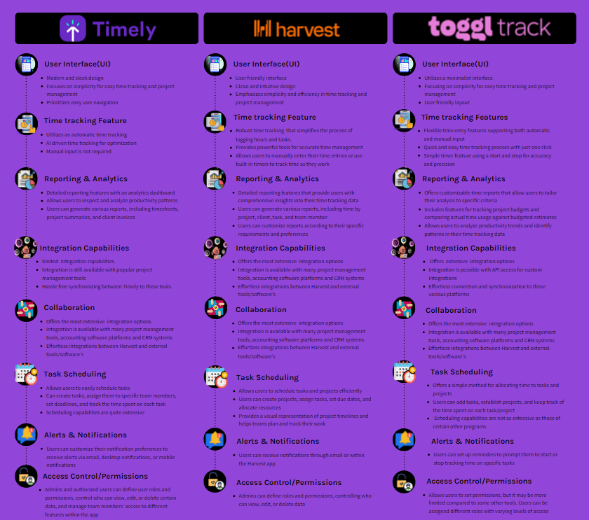

## **3. Innovative features to include**

From Timely:

* **Visual Task Planning**:

Explanation: This feature enables users to create a visual schedule. This gives users a concise breakdown of their day and promotes effective task planning.

**Motivation**:   
Enhanced User Engagement: A calendar format may be more user-friendly and interesting, particularly for those who are visually inclined.   
Better Time Management: Users can plan and prioritize work more strategically when they have a better understanding of how their time is spent thanks to visualization.



(Google, 2024)

* **Automatic Time Tracking**:

Explanation: This function uses the computer's activity to automatically track the amount of time spent on tasks, this lowers user effort and increases data accuracy.

**Motivation**:   
Decreased User Burden: By eliminating the requirement for users to remember to start and stop timers, human input and mistake risk are reduced.   
Increased Data Accuracy: Since automatic tracking removes the chance of forgetting to log time, the data is more trustworthy and suitable for analysis.

(Google, 2024)

* **Idle detection**:

**explanation**: This function recognizes idle times and subtracts them from the overall recorded duration. This makes it easier to discern between productive work time and distractions or breaks.   
**Motivation**:   
**Encouragement of Focus**: It serves as a reminder to users when they haven't been actively involved, which may lead them to reduce outside distractions and concentrate more on their task.   
**Providing Accurate Data**: Real work duration and production are better understood when idle time is excluded.

* **Bulk editing**:

The explanation for this feature is that it saves time and effort by enabling users to update or modify numerous time entries at once, as opposed to altering each one separately.

**Motivation**:

**Enhanced Productivity**: Editing several entries at once can help users save time and effort, particularly when doing repetitive tasks.   
Improved User Experience: For users who enter a lot of time, bulk editing makes the software more convenient and easier to use.

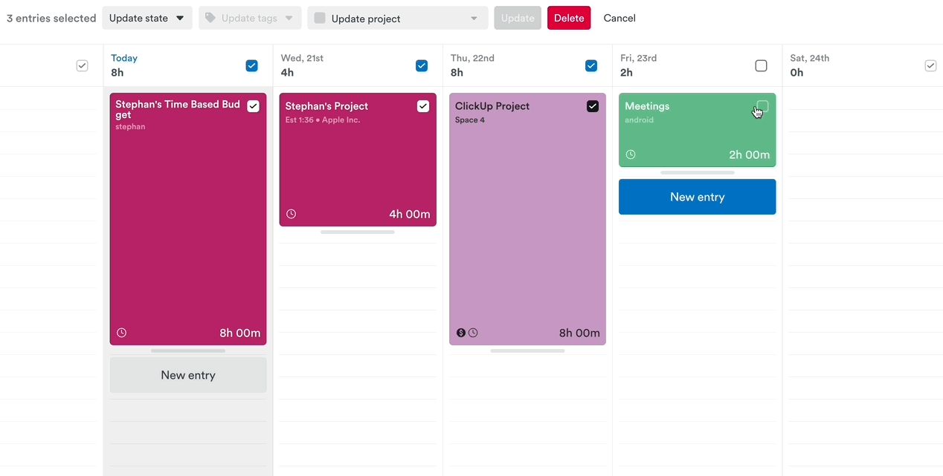 (Lisa, 2024)

**From Toggl Track**:

* **Offline Tracking**:

**Explanation**: This function lets users keep track of their time even when they're not online. The application saves the information locally and, when an internet connection is available, syncs it with the cloud.

**Motivation**:

**Increased Flexibility**: When tracking time when offline or in places with spotty internet access, users can be sure that their data is being collected.   
Enhanced Data Reliability: By utilizing offline monitoring, worries regarding data loss resulting from internet connectivity problems are removed.

(Vedran, 2024)

* **Free Plan with Basic Features**:

**Explanation**: Toggl Track provides a free plan that includes basic reporting, project management, and time tracking, among other vital features. This enables customers to test out the app before signing up for a premium membership.   
**Motivation**: Draws in New Users: Before purchasing a premium plan, a free tier enables users to test the software and see its value, this could eventually result in paying consumers.   
Expands your User Base A free plan can draw in more users and provide you with useful user feedback and data for future development.

(Toggl, 2024)

From Harvest:

* **Simple and intuitive time tracking**

**Explanation**: Harvest provides an easy-to-use time tracking interface.

**People may**:

You may start and end timers right from within the app, desktop widget, or browser extension.   
Timesheets for tasks done outside of the app can be manually entered.   
For appropriate invoicing, distinguish between billable and non-billable hours.   
Sort monitored time according to client, task, and project.  
Motivation: By using an easy technique, time monitoring becomes consistent and reliable, producing useful data for project management as well as individual productivity.

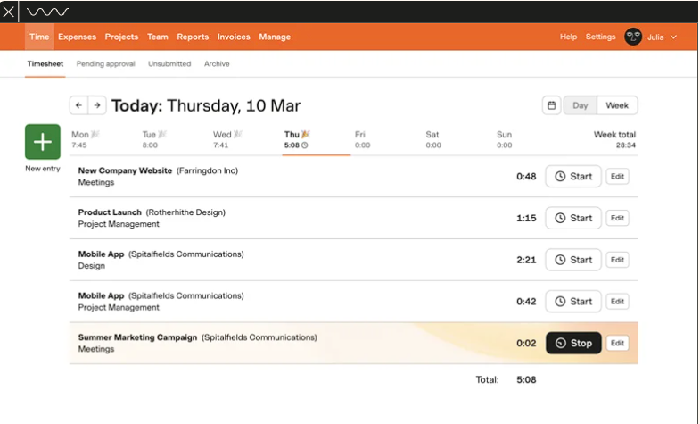

(Harvest, 2024)

## **Conclusion** The application will implement multiple functionalities and processes that will allow the app to uphold the goals set upon the application. Multiple other app innovative features (from Timely, Harvest and Toggl Track) have been described and studied on how and why these features are successful and with these features understood as well as extensively researched on their specific advantages and disadvantages, the approach to making ClockSavvy (The application name) will be considered very carefully and implemented in a newer yet classical way with these supporting studies. With these studies set in place the architecture design will follow a complex design that will give ClockSavvy an edge in functionality ultimately automating the experience for the user in a back-end perception. In a front-end perception ClockSavvy will follow a classical look and feel making the user not feel overwhelmed and making the experience in a gamification form. The idea of ClockSavvy is to make it easier yet fun for the user to time manage their day to day timing experience and we aim to strive for these goals to be set in motion and place.

## **5.Reference List**

crozdesk (2024) *Timely | software reviews & alternatives*, *Timely*. Available at: https://crozdesk.com/software/timely (Accessed: 20 March 2024).

GetApp (2024) *TOGGL Track Reviews - Pros & Cons, Ratings & More | Getapp*, *Toggl Track*. Available at: https://www.getapp.com/project-management-planning-software/a/toggl/reviews/ (Accessed: 20 March 2024).

GetApp (2024a) *Harvest vs TOGGL track comparison | getapp*, *Harvest versus Toggl Track comparisons*. Available at: https://www.getapp.com/finance-accounting-software/a/harvest-time-tracking-and-online-invoicing/compare/toggl/ (Accessed: 20 March 2024).

Google Play (2024) *Timely automatic time tracking - apps on Google Play*, *Google*. Available at: https://play.google.com/store/apps/details?id=com.timeapp.devlpmp&hl=en&gl=US (Accessed: 20 March 2024).

Google Play (2024b) *TOGGL track - android apps on Google Play*, *Google*. Available at: https://play.google.com/store/search?q=toggl+track&c=apps&hl=en&gl=US (Accessed: 20 March 2024).

Harvest (2024) *Time Management Strategies that improve time management skills*, *Harvest*. Available at: https://www.getharvest.com/resources/time-management-strategies (Accessed: 20 March 2024).

Harvest (2024a) *Time tracking for those who value insight*, *Harvest*. Available at: https://www.getharvest.com/harvest-time-tracking?chan=Google&device=c&kw=%2Bharvest+%2Btimer&loc=1028682&camp=445034609&adgr=29583837809&type=brand&utm_term=%2Bharvest+%2Btimer&utm_campaign=EMEA%2BHarvest%2B-%2BBrand%2B-%2BAll&utm_source=adwords&utm_medium=ppc&hsa_acc=4436465424&hsa_cam=445034609&hsa_grp=29583837809&hsa_ad=649829003454&hsa_src=g&hsa_tgt=kwd-34467572804&hsa_kw=%2Bharvest+%2Btimer&hsa_mt=b&hsa_net=adwords&hsa_ver=3&gad_source=1&gclid=CjwKCAjwkuqvBhAQEiwA65XxQF1RL0JHTKcqfaz0wzT09vNfY83QMdMcOqgXy89iRzlxsGHK_YLvhxoCb8MQAvD_BwE (Accessed: 20 March 2024).

Replogle, N. (2023) *6 best time tracking apps in 2024*, *Zapier*. Available at: https://zapier.com/blog/best-time-tracking-apps/ (Accessed: 20 March 2024).

Santos, J.M.D. (2023) *TOGGL Track Review: Features, Pricing & User Reviews*, *project*. Available at: https://project-management.com/toggl-software-review/ (Accessed: 20 March 2024).

Santos, J.M.D. (2023a) *Harvest review: Features, pricing & user reviews*, *project*. Available at: https://project-management.com/harvest-software-review/ (Accessed: 20 March 2024).

Software Advice (2024) *Timely reviews*, *Timely Software Reviews, Pros and Cons - 2024 Software Advice*. Available at: https://www.softwareadvice.com/za/employee-monitoring/timely-profile/reviews/?review.rating=4 (Accessed: 20 March 2024).

Timely (2024) *AI-Powered Time Tracking Software*, *Timely*. Available at: https://timelyapp.com/#:~:text=Automate%20your%20time%20tracking,desktop%20app%20automatically%20for%20you. (Accessed: 20 March 2024).

Timely (2024a) *Ai timesheets*, *Timely Features*. Available at: https://timelyapp.com/feature/ai-timesheets (Accessed: 20 March 2024).

Timely (2024b) *Track time*, *Timely*. Available at: https://timelyapp.webflow.io/features/automatic-time-tracking (Accessed: 20 March 2024).

Timely (2024c) *The memory app - see everything you work on each day*, *The Memory App - See everything you work on each day*. Available at: https://timelyapp.com/memory-app (Accessed: 20 March 2024).

Timely (2024d) *Time Planning*, *Timely Features*. Available at: https://timelyapp.com/feature/time-planning (Accessed: 20 March 2024).

Toggl (2006) *TOGGL track: Time Tracking Software for any workflow*, *Toggl Track: Time Tracking Software for Any Workflow*. Available at: https://toggl.com/ (Accessed: 20 March 2024).

Toggl (2006a) *Time Tracking for Invoicing & Billing: Toggl track*, *Time Tracking for Invoicing & Billing | Toggl Track*. Available at: https://toggl.com/track/time-tracking-invoicing/ (Accessed: 20 March 2024).

Toggl (2006b) *Online time reporting software [free]: Toggl track*, *Online Time Reporting Software [FREE] | Toggl Track*. Available at: https://toggl.com/track/online-time-reporting/ (Accessed: 20 March 2024).